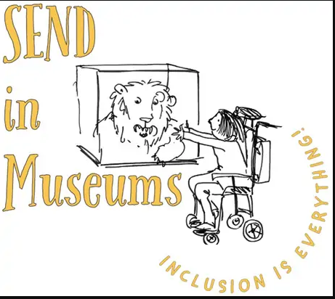
Shapes and patterns
Our museum is full of shapes and patterns. Look at the building and objects to find these…

Square Triangle Circle Rectangle
Hexagon Arch Dots Flower
Leaf Wave Zig zag Mosaic

