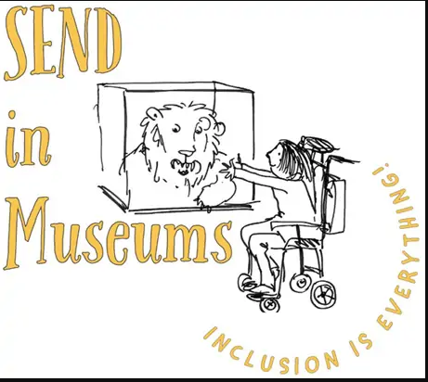
Create a mini museum

Explore the Haworth Art Gallery to discover some favourite objects. Is it a vase? Or is it a painting?
Draw them in the case below.

