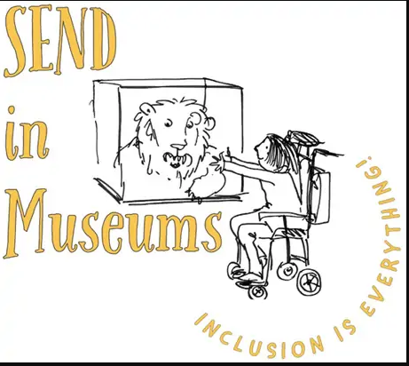
Storytime
Choose a character from the museum and pick an object from the display. Think of an exciting place they could go. What happens next? You decide…

Tell your story to friends and family or have fun making it together. Act it out or make it into a poem or song.

Use this space if you want to write it down…

