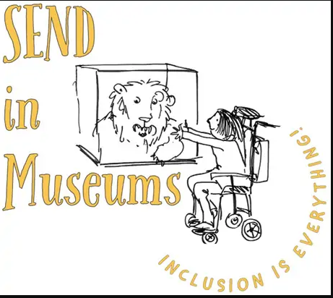
Amazing objects
Find an amazing object. What is it? Why is it special?

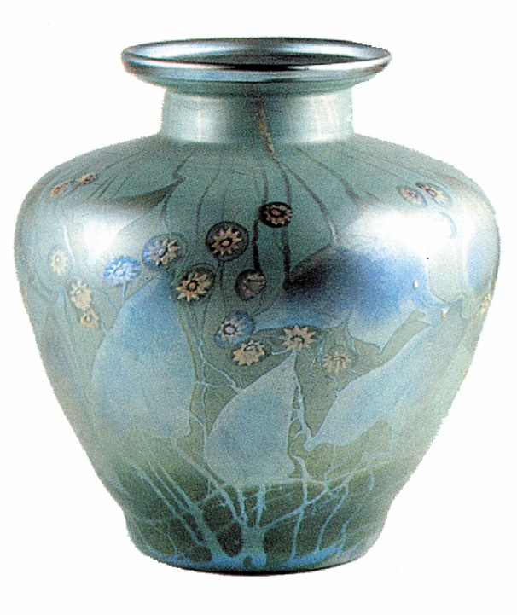

Creative idea. Why not make a Top Trumps style game of favourite museum objects? Categories might include age of artefact, importance, size and how rare they are. Take some photos, then make and play the game when you get home.

