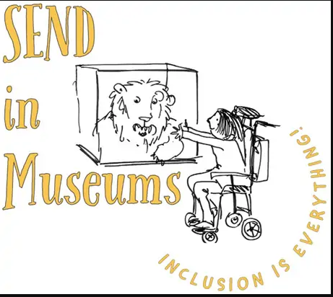
As Still as Mercury

Explore the galleries to find where Mercury is hiding!
A sculpture is a piece of 3-dimensional art. Look at it closely from all angles!
Describe what it looks like.
What’s it made of?
Do you like it?

Activities:
Draw your own piece of sculpture on the plinth below.

