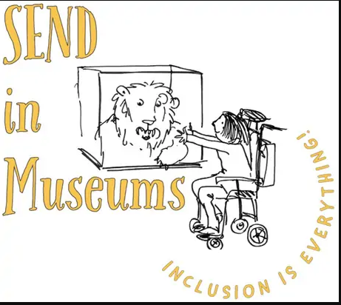
Send a Postcard from Haworth Art Gallery

Design a colourful postcard to send to family or friends.
Tell them about your trip to the Gallery and the best things you found.
Top tip
Print this activity sheet on white A4 card and cut-out the postcard template before you draw your design. Draw on the blank side and write a message to send to someone on this side! Don’t forget to add a stamp before you post it!
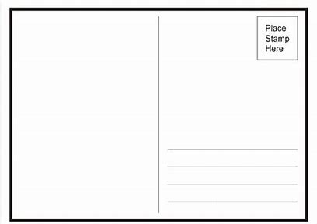
Idea: Why not share a photo of your postcard on the Museum’s Facebook page?!
https://www.facebook.com/HaworthArtGalleryAccrington

